Name- Swapnil Pal
WEEK 5-6 Documentation

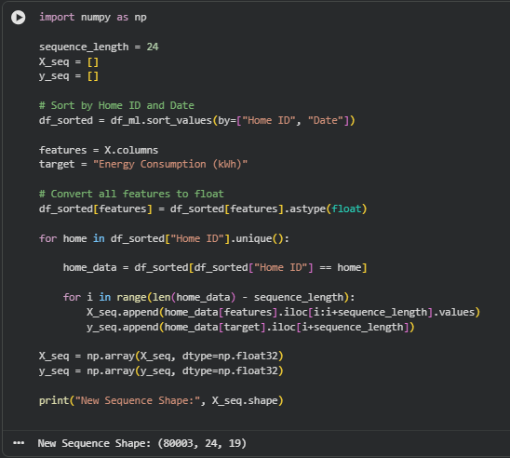

This code prepares time-series sequences of length 24 for each home by sorting data by Home ID and Date, then applying a sliding window technique.
It converts features to float, generates input sequences (X_seq) and corresponding target values (y_seq), and finally produces a dataset of shape (80003, 24, 19) for model training.
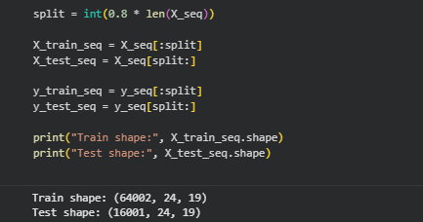

This code splits the sequence dataset into 80% training and 20% testing using split = int(0.8 * len(X_seq)).
The training set contains 64,002 samples and the test set contains 16,001 samples, each with a shape of (24, 19), indicating 24 time steps and 19 features per sample.\

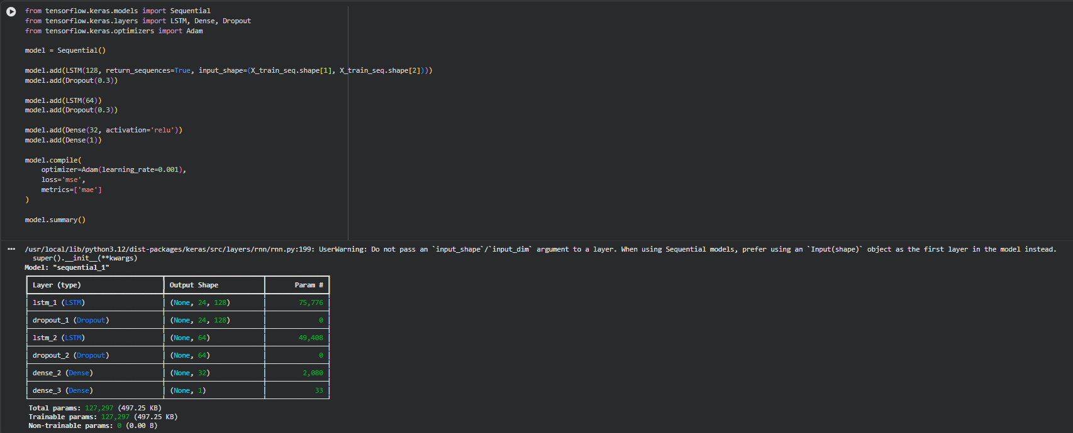

This code builds an LSTM-based deep learning model with two LSTM layers and dropout for predicting energy consumption from time-series data.
It uses Adam optimizer, MSE loss, and MAE metric, and outputs a single value, with a total of 127,297 trainable parameters.

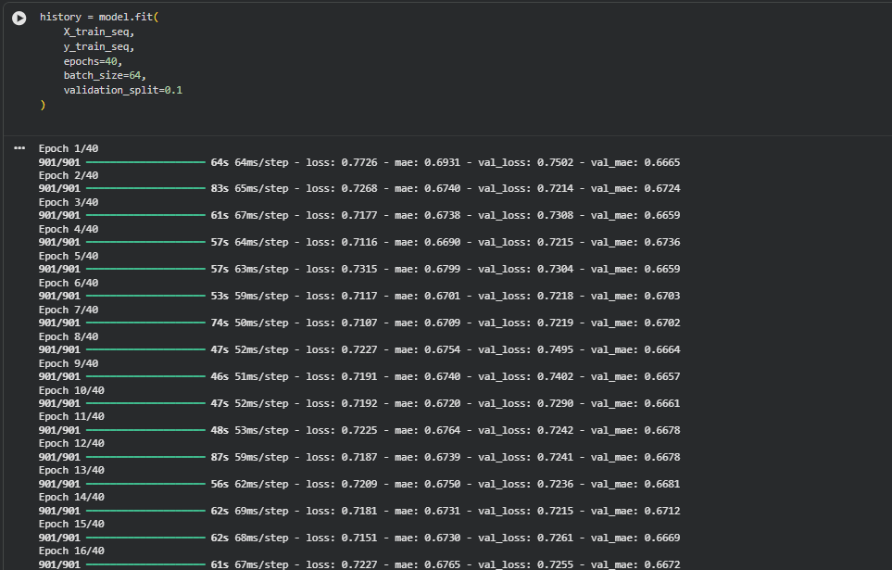

This code trains the LSTM model using the training sequences for 40 epochs with a batch size of 64 and a 10% validation split.
The training and validation losses gradually decrease, showing that the model is learning patterns while maintaining stable performance without major overfitting.

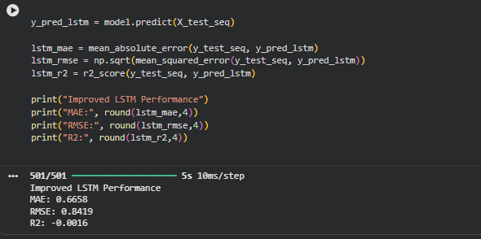
This code uses the trained LSTM model to predict energy consumption on the test dataset and evaluates its performance.
The results show MAE = 0.6658, RMSE = 0.8419, and R² = -0.0016, indicating moderate prediction error and weak explanatory power on unseen data.

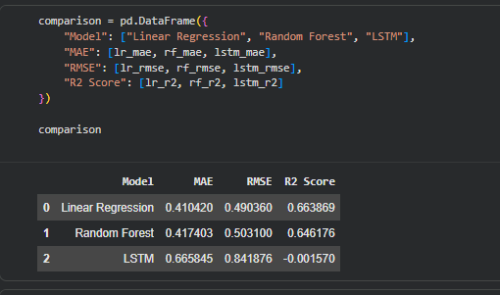

This code creates a comparison table to evaluate Linear Regression, Random Forest, and LSTM models using MAE, RMSE, and R² scores.
The results show that Linear Regression and Random Forest perform better than LSTM, while the LSTM model has higher errors and a negative R², indicating poor predictive performance.

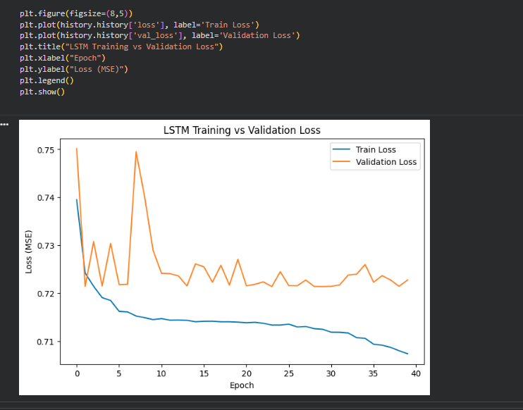

This plot shows the training and validation loss (MSE) of the LSTM model over 40 epochs.
The training loss steadily decreases, while the validation loss remains almost constant with small fluctuations, indicating limited improvement on unseen data and possible underfitting.

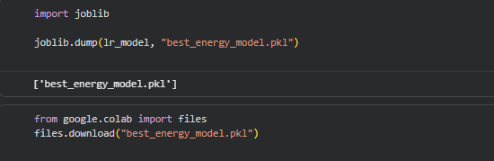

This code saves the trained Linear Regression model using joblib into a file named best_energy_model.pkl.
It then downloads the saved model from Google Colab, allowing it to be reused later for prediction without retraining.

If you want, I can help you push this from “good” to “very strong” by adding:1) cross-validation,2) hyperparameter tuning for RF/XGBoost,3) proper train/val/test report + residual plots,4) model card section in website showing real metrics.

The above para is left

